My rights: nothing about me, without me

Easy English book

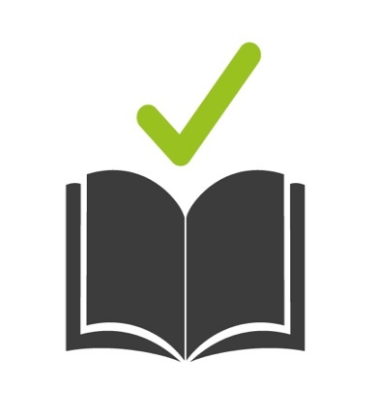 | How to use this book  This book is by Life Without Barriers.  It is in Easy English.  We use pictures to help people know what it is about.  Some words are in blue and we will tell you what the words mean.

What is this book about?
This book is about your rights.
Some people with disability have helped write this book.

 | What are your rights?
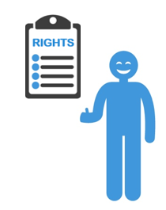 | A right is a rule that says what all people can expect to have and do in their life.  It is something that should not be taken away from you.  People who don’t let you have your rights can get in trouble.
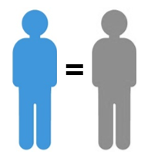 | You have equal rights and opportunities  This means you won’t be treated differently or unfairly because you are different to someone else.
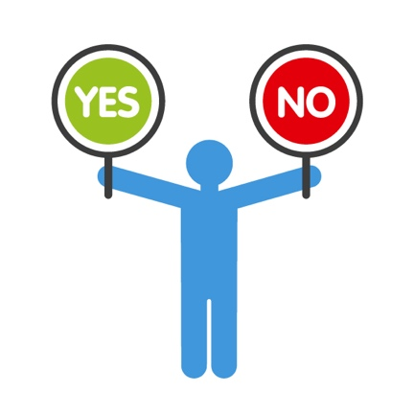 | You can make your own choices  This means you get to decide what you do and want in your life.
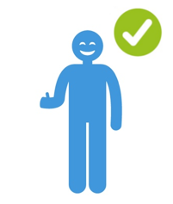 | You are respected for who you are  This means you are allowed to have different ideas and interests and feelings about things.
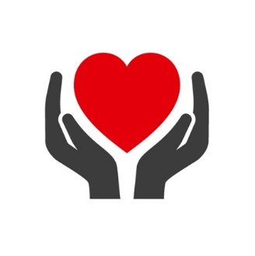  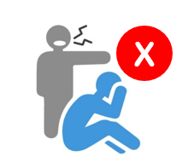 | You are safe  This means you will not be hurt, yelled at, left alone for a long time without help, or exploited by anyone.  Exploited means someone is using you unfairly to get something from you, such as your money.
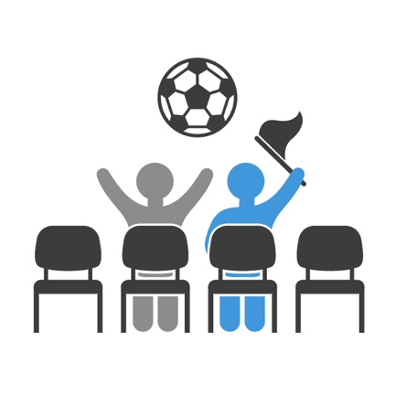 | You are part of the community  This means you can do the things you want in the community, just like anyone else.
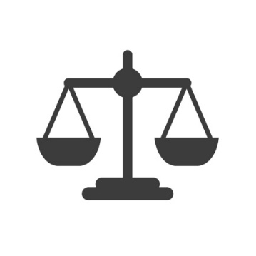 | You get justice  Justice means someone will help you if you are not getting your rights.  You can tell the police or someone you trust if you have been hurt or something does not feel right.
 | What if you are not getting your rights?
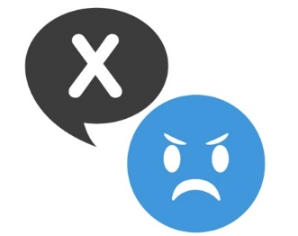 | We want you to tell us if you are not getting your rights so we can fix things.
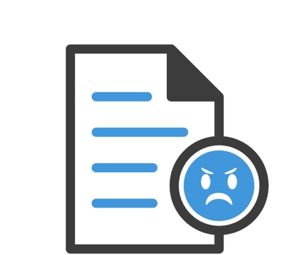 | We have a special document that tells you how you can tell us if you are not happy.  It is called the Complaints and Feedback Policy.
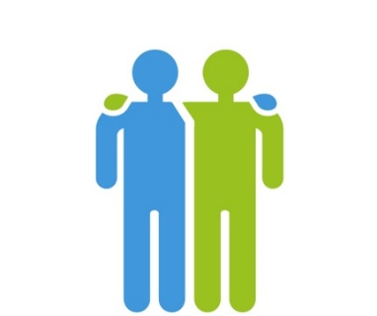 | Your support team can give it to you and read it to you.  You can also ask someone you trust, like a family member or a friend, to tell us if you are not happy.

This Easy English document was created by Life Without Barriers. We support and encourage the use of Easy English and accessible materials so every person may have the opportunity to engage with and understand important information about our services

